Appendix B: The Impulse Collision Method Algorithm
a.1) For a particle-particle interaction, calculate the relative position vector 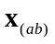
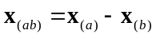 and its norm 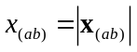
a.2) Compute the overlap (penetration depth)
a) 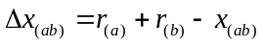 – in case of particle-particle interaction
b) 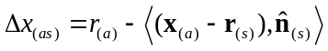 – in case of particle-surface interaction
The two objects interact (have a contact), if the overlap is positive, i.e. if
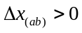 alt. 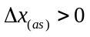
 Proceed with steps (b) and (c) only for objects that overlaps.
b.1) For particle-particle interaction, calculate the unit collision direction from b to a, i.e.
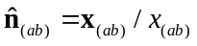 (for particle-surface interaction we already have 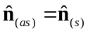)
b.2) Calculate the velocity projection 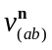 on the unit collision direction 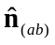 as scalar product
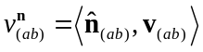
We can distinguish three cases:
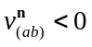 – impacting contact
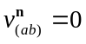 – resting contact
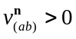 – separating contact
 Proceed with (c) only in case of impacting contact when using the impulse interaction method.
c.1) Calculate the reduced mass to particle mass ratio 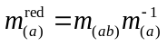
a) 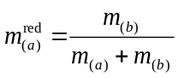 – in case of particle-particle interaction, when 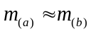
b) 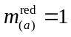 – in case of particle-surface interaction, when 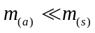
c.2) Calculate the scalar component of the velocity jolt 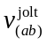
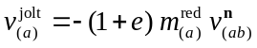 (note that for impacting contact, so 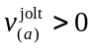)
c.3) Calculate the tangential unit vector of contact
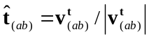 where 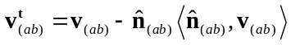
c.4) Calculate the velocity jolt (where 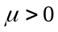 in case of friction)
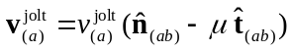 and clip 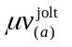 term not to exceed 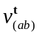 component (!)
c.5) Calculate the position projection
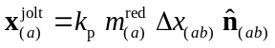 (note that 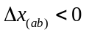 since objects are in contact)
c.6) Apply the velocity jolt and the position projection when appropriate (e.g. in the odd half-step of the leapfrog integrator to keep external forces balanced)
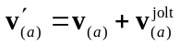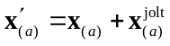

Notes on Two-body Collision Impulses
Let us introduce a velocity jolt 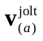 as the change of the velocity of a particle a during the hardcore interaction, i.e.
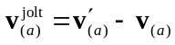
Then, from Eq. (5.11) 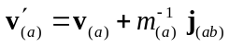 we have
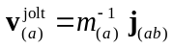
and further, from Eq. (5.14) 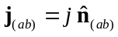, we get expression for the velocity jolt
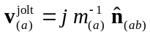
On the other hand, substituting impulse j from Eq. (5.16)
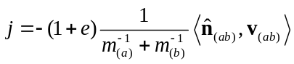 (5.16)
into Eq. yields
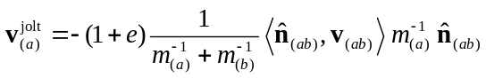
Denoting as the projection of the velocity 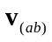 on the unit collision direction (from particle b to particle a), and substituting into Eq. , we get
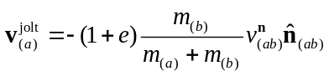.
At this point, it is convenient to introduce a reduced mass 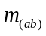 of a two-body system as 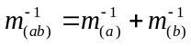 and the reduced mass to particle a ratio i.e.
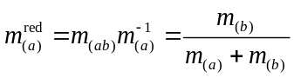
Substituting the last reduced mass to particle ratio into gives
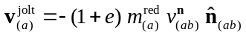.
If we further denote as 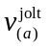 the scalar component of the velocity jolt 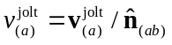, then
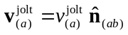
and from Eq.
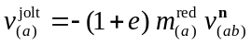
Combining Eq. with Eq. , we get also relationships
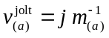 i.e. 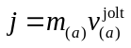.

Notes on Collision Impulses with the Static Surface
We can assume that the mass of the surface is 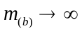. In this case the reduced mass to particle ratio 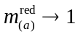 and Eq. becomes
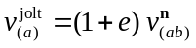

Notes on Simplified Frictional Collision Impulses
Applying the triple vector product rule 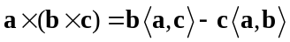 to modified Eq. (5.25)
where 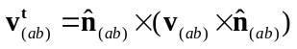 (5.25)
which gives
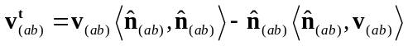
Recalling from earlier that and since 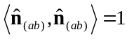, the last expression becomes
and
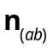
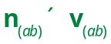
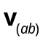
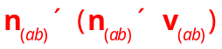
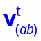
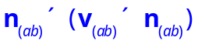
Note that Eq. can be calculated for any number of spatial dimensions (1, 2 or 3), while Eq. (5.25) can be calculated only for three-dimensional vectors (cross product operation requires arrays of length 3).
From performance view, Eq. consists of one scalar multiplication (with velocity projection scalar product calculated earlier) and vector subtraction. This is much faster than two cross products from Eq. (5.25) and also easier to “vectorize” for many-particle system (e.g. in MATLAB).

Finally, since
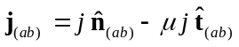
it follows
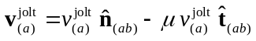

Notes on Position Projections
A position projections factor k_{p} is introduced into equations (5.27) and (5.28) found in Projections subsection in Notes. The modified expressions for the position projections (with the factor k_{p}) are then
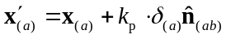 (5.27)
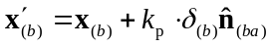, 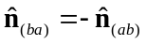 (5.28)
The projection factor k_{p} values are in range from 0 to 1, where the factor k_{p} = 0 disables position projections and k_{p} = 1 enables projections in full extent.
Other values 0 < k_{p} < 1 make position projections to act like a spring (softening displacements).
Let us denote with 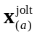 a position projection, i.e. as the change of the position of a particle a during the hardcore interaction
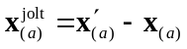
Then, from Eq. (5.27) 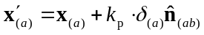 we have
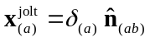
Since, from Eq. (5.29)
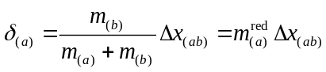
the position projection is
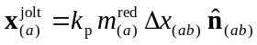

Position projection factor seen as spring stiffness
Substituting 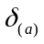 from Eq. (5.29) in Notes into earlier modified Eq. (5.27) (with k_{p}), we get
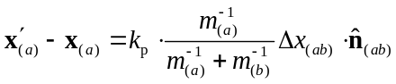
On the other side, from the integrator algorithm perspective, the position projection can be seen as there is an ad-hoc spring force 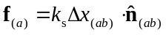 giving the same position displacement during the integrator time-step (but not influencing the velocity, however)
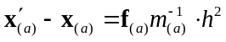 i.e.
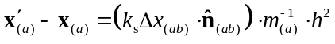
Combining equations and yields
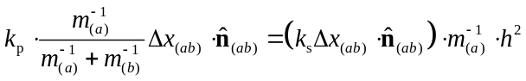
Finally, canceling 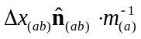 and substituting 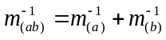 yields the relation
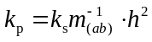
Since the semi-implicit Euler integrator method is assumed stable for 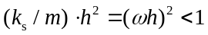, then, for 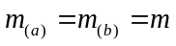, it follows from , that the same method is stable for the position projection factors 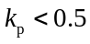.

Orientation of a plane and plane impenetrability
Inequality (5.8) for contact and expression (5.9) for overlap in section 5.2.2 in Notes can produce bugs. Namely, since 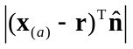 is an absolute (always positive) distance between a particle and a plane, the inequality (5.9) does not distinguish sides of the plane.
As one of the sides of the plane is impenetrable (the side opposite to the normal unit vector ), the correct expression for the overlap (actually the penetration) is:
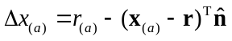 modified (5.9)
and the condition for contact is/when:
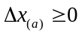 modified (5.8)
Motivation 1
The equations (5.8) and (5.9) are mentioned to be used for detecting contacts in collisions with surfaces. However, the equations fail with a finite time-step integrator in case when:
- a particle has a high velocity, or
- a particle has a very small size, or
- time-step is too large.
In such cases the integrator can “tunnel” a particle through the surface without noticing that there was a contact (left case on Figure A.1)! In particular, tunneling might happen if r < h v, where r is particle radius, h is time-step size and v is particle velocity. However, a box wall or ground surfaces should not be ‘transparent’ for particles in classical mechanics (right case on Figure A.1).
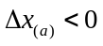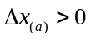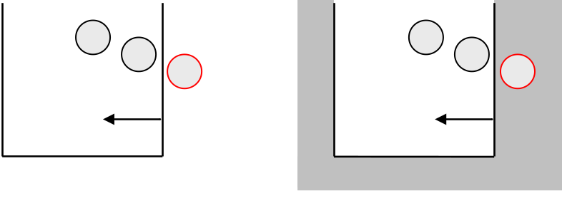
tunneling
Figure A.1: Tunneling of a particle with unmodified (5.9) giving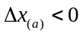 (left case)
So, the collision detection algorithm based on Eqs. (5.8-9) has a bug, which makes usage of the equations erroneous. Otherwise, one has to ensure that particle velocities in a system does not become larger than r/h, which seems as an unreasonable requirement.
Motivation 2
Another way to look on this problem is to perceive an Euclidian plain as a limit of the sphere with center 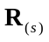 at infinity and having infinite radius 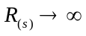. In this case, follows from Eq. (5.4), i.e. from 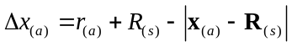 (given here without proof).
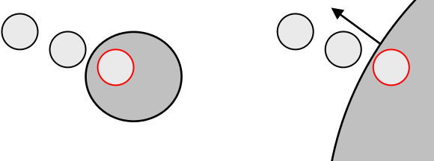
Figure A.2: Collision with a plain seen as a collision with sphere of an infinite radius

